**Essential Tools to Prepare for the Modern Workplace**

**University Workshop Series 2021: Setting Up Your Tools**

Contents

Setting Up Power Query/Power Pivot 2

Setting Up a Power Apps Account 4

Setting Up a Student Azure Account 7

# Setting Up Power Query/Power Pivot

1. Open an Excel workbook and check if the Data Ribbon and Power Pivot Ribbon is already displayed. *If you are using Excel for Mac, please refer to Point 5.*

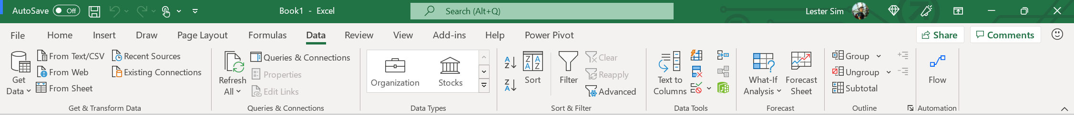

1. To display the Data Ribbon, click **File > Options > Customize Ribbon** and ensure that the Data Tab checkbox is checked. Click Ok.

1. To display the Power Pivot Ribbon, click **File** > **Options** > **Add-ins**. At the bottom of the window under **Manage** > Click **COM Add-ins** > Click **Go.** Check **Microsoft Power Pivot for Excel** and click Ok. Close and restart Excel.

1. Both the **Data** Ribbon and **Power Pivot** Ribbon should now be displayed.
2. *Please note that you will need a* ***Windows operating system*** *to follow along for this session. Excel for Mac currently only supports limited Power Query capabilities - importing and refreshing data sources. More integrations between Excel for Mac and Power Query will be announced in future releases. If you are using a non-Windows OS, you may still attend the workshop to understand how you can use Power Query in the future.*

# Setting Up a Power Apps Account

1. Set up an Office 365 E5 Trial: Go to: [aka.ms/tryofficeE5](https://aka.ms/tryOfficeE5) and fill up the form with your **personal email and NOT your work/school email.** Click set up account.

*Note: Click logout and create new account instead if you have in logged in with other accounts previously.*

1. Fill in your details.

1. In the next step, choose a domain name for yourself and a username. For example, [admin@ocsiad.onmicrosoft.com](mailto:admin@ocsiad.onmicrosoft.com). Take note of this account you have just created.

1. Next, visit <https://docs.microsoft.com/en-us/ai-builder/administer-licensing>. Under the **Get Started** section, click on “**Start your free trial**”.

1. Enter the email address that you’ve just created in step 3.

*Note: Click logout and create new account instead if you have logged in with other accounts previously.*

1. Once done, you’ll see the following screen.

1. Click Get Started and it will re-route you to the Power Apps homepage. Now you’re all set and ready to get started with Power Apps!

# Setting Up a Student Azure Account

1. Navigate to <https://azure.microsoft.com/en-gb/free/students/>
2. Click the green button: Start for Free

1. Sign in with your university email address – this should prompt you to log in via your institution.

*For registering with personal emails, please visit this link:* [*Create your Azure free account today | Microsoft Azure*](https://azure.microsoft.com/en-gb/free/)*. Note there will be a few more verification steps.*

1. Complete your profile to receive $100 in Azure credits as well as access to services you will need for the upcoming Azure workshop!

1. Once your new account is set up it will redirect you to the page below. Now you’re all set and ready to get started with Azure!

